Software Design Document

<Project Name>

Student Names

Table of Contents

1.0 System Vision 3

1.1 Problem Background 3

1.2 System Overview 3

1.3 Potential Benefits 3

2.0 Requirements 4

2.1 User Requirements 4

2.2 Software Requirements 4

2.3 Use Cases 4

3.0 System Components and Software Design 5

3.1 System Components 5

3.2 Software Design 5

4.0 User Interface Design 6

# System Vision

## Problem Background

The effective management of road safety and the formulation of informed policy decisions heavily rely on accurate and comprehensive data concerning road accidents. Over the years, VicRoads has played a vital role in collecting accident data, shedding light on trends and patterns. However, as road safety challenges continue to evolve, the need for an advanced and modernized accident data collection system becomes apparent. To address this, the Victoria State Accident DataSet 2015-2020 (VSADS) project is initiated.

The existing accident data collection system operated by VicRoads has been a resource for understanding accident occurrences. Yet, the VSADS project aims to visualise this database. The proposed project seeks to harness the dataset collected by VicRoads during the years 2015-2020, leveraging visualizations to provide deeper insights into accident data. This project is intended to empower decision-makers, facilitate resource allocation, and strengthen public safety measures.

## System Overview

The VSADS project envisions the creation of a Data-Visualization tool that eases the way accident data is collected, analysed, and utilized. The core focus of this tool is to offer a user-friendly interface equipped with visualisation capabilities. Through this tool, users will be able to explore accident data from 2015 to 2020 in a comprehensive and visually engaging manner. The key components of the system include:

* **Accident Information Display:** Users can select a specific time period and view detailed information about all accidents that occurred during that period. This feature provides a comprehensive overview of accident data within the user's chosen timeframe.
* **Hourly Accident Trends:** The system will generate charts that illustrate the average number of accidents for each hour of the day within the selected time period. This analysis offers insights into the temporal distribution of accidents.
* **Keyword-Based Accident Retrieval:** Users can retrieve accident data related to specific accident types by entering keywords. For instance, users can search for accidents involving terms like "collision" or "pedestrian," which helps in understanding the prevalence of particular accident types.
* **Alcohol Impact Analysis:** The tool will enable users to delve into the impact of alcohol in accidents. It allows users to explore trends over time, identify accident types involving alcohol, and gain insights into alcohol-related road safety challenges.
* **Geospatial Visualization:** An innovative geospatial data visualization component will be integrated, enabling users to visualize accident locations on a state map for their selected time period. This feature provides a spatial understanding of accident hotspots and distribution.

## Potential Benefits

The implementation of the VSADS project and its associated Data-Visualization tool offers a multitude of potential benefits for various stakeholders:

* **Informed Decision-Making**: The advanced analytical capabilities of the tool empower decision-makers, allowing them to make more informed choices in resource allocation, policy formulation, and road safety improvements.
* **Enhanced Public Safety:** By gaining deeper insights into accident data and patterns, public safety measures can be tailored more effectively to address specific areas of concern, reducing accidents and their impact on communities.
* **Efficient Resource Allocation:** With accurate and easily accessible accident data, authorities can allocate resources more efficiently, targeting high-risk areas and implementing proactive safety measures.
* **User-Friendly Interface:** The user-friendly interface ensures that a broader range of users, including non-technical stakeholders, can access and interpret accident data, fostering collaboration between different sectors.
* **Comprehensive Analysis:** The tool's comprehensive analysis capabilities enable researchers, analysts, and policymakers to delve into accident data from various angles, fostering a better understanding of road safety challenges and potential solutions.

In essence, the VSADS project aspires to assist accident data analysis, making it more accessible, insightful, and impactful for the benefit of both road safety authorities and the broader community in Victoria.

# Requirements

## User Requirements

To effectively interact with the VSADS Data-Visualization tool, users should experience a seamless and intuitive process that allows them to access, analyse, and gain insights from the accident data present. The envisioned end user for this software could be a road safety analyst within a government agency or a researcher within an academic institution. Here's how they will interact with the program:

1. **User Authentication and Dashboard**:

* Users should be able to log in securely using their unique credentials .
* Upon successful login, users are directed to a personalized dashboard.

1. **Data Selection and Time Period**:

* Users can select the time period they want to analyse, defining the start and end dates.
* The interface should offer intuitive controls, such as drop-down menus or date pickers, to facilitate accurate date selection.

1. **Accident Information Display:**

* Users can view a summarized list of accidents that occurred within the selected time period.
* Each accident entry should include key information, such as date, time, location, and accident type.

1. **Hourly Accident Trends:**

* Users can access an interactive chart that visualizes the average number of accidents for each hour of the day within the selected time period.
* The chart should offer tooltips or labels for easy interpretation.

1. **Keyword-Based Search:**

* Users can enter specific keywords related to accident types (e.g., "collision," "pedestrian") to retrieve accidents matching the entered criteria.
* The system should provide instant feedback as users type, helping them identify relevant keywords.

1. **Alcohol Impact Analysis:**

* Users should be able to navigate to a dedicated section for alcohol-related accident analysis.
* The section should offer various filters and visualization options to explore alcohol's impact on accidents over time and by accident type.

1. **Geospatial Accident Visualization:**

* Users can access a map-based interface that displays accident locations on a state map within the selected time period.

1. **Help and Support:**

* Users should have access to a user manual or help section that provides guidance on using the various features of the tool.

1. **User-Friendly Interface:**

* The interface should be visually appealing, well-organised.

## Software Requirements

The VSADS Data-Visualization tool is designed to provide a comprehensive set of functionalities that allows the users to effectively interact with the accident data and gain valuable insights. These functionalities are defined as software requirements using a formal listing:

**R2.1 User Dashboard:**

* The dashboard shall offer clear navigation to different sections of the tool.

**R2.3 Time Period Selection:**

* The system shall allow users to define the start and end dates for the time period they wish to analyse.
* Users shall be able to adjust the time period using intuitive controls.

**R2.4 Accident Information Display:**

* The system shall present a summary list of accidents that occurred within the selected time period.
* Each accident entry shall include the date, time, location, and accident type.

**R2.5 Hourly Accident Trends:**

* The system shall generate an interactive chart illustrating the average number of accidents for each hour of the day within the selected time period.
* Users shall be able to interact with the chart, such as hovering for details.

**R2.6 Keyword-Based Search:**

* The system shall provide a search function that enables users to enter keywords related to accident types (e.g., "collision," "pedestrian").
* The search results shall display accidents matching the entered keywords.

**R2.7 Alcohol Impact Analysis:**

* The system shall offer a dedicated section for alcohol-related accident analysis.
* Users shall have options to filter and visualize trends related to alcohol-involved accidents.

**R2.8 Geospatial Accident Visualization:**

* The system shall incorporate a map-based interface displaying accident locations on a state map within the selected time period.
* Users shall be able to zoom in/out and click on markers for detailed information.

**R2.9 Export and Reporting:**

* The system shall allow users to export charts, visualizations, and accident information to formats such as PDF or CSV.
* The export function shall be easily accessible within relevant sections.

**R2.10 Help and Support:**

* The system shall provide a comprehensive user manual or help section accessible from the dashboard.
* Users shall be able to contact support for technical assistance.

**R2.11 Responsive Interface:**

* The system shall ensure a responsive design that adapts to different devices, including desktop, tablet, and mobile.

**R2.12 Data Privacy and Security:**

* The system shall adhere to data privacy regulations and best practices, ensuring the confidentiality and security of user data.

These software requirements define the core functionalities of the VSADS Data-Visualization tool, ensuring a seamless and efficient user experience for exploring accident data and gaining insights.

## Use Cases & Use Case Diagrams

In the VSADS Data Visualisation project, this tool has been developed to transform the way accident data is analysed and harnessed. This tool caters to the needs of diverse stakeholders, including road safety analysts and policy makers, empowering them to unravel critical insights from the wealth of accident data collected by VicRoads.  
  
These use cases epitomize the impact of the VSADS Data-Visualization tool. By enabling stakeholders to extract actionable insights from accident data, the tool paves the way for data-driven road safety enhancements, informed policy decisions, and ultimately, safer roads for the community of Victoria.

**Use Case 1: Road Safety Analyst's Accident Trend Analysis**

In this use case, a Road Safety Analyst uses the Data-Visualization tool to delve into accident trends within specific time periods. By exploring hourly accident patterns, utilizing keyword-based searches, and dissecting the impact of alcohol on accidents, analysts can pinpoint patterns, hotspots, and prevalent accident scenarios. This tool assists analysts in making well-informed recommendations for road safety improvements and resource allocation. The user-friendly interface and interactive visualizations enable seamless data interpretation, fostering efficient collaboration across sectors.

**Use Case 2: Policy Maker's Resource Allocation Decision**

For Policy Makers, the Data-Visualization tool serves as a strategic asset. By examining accident data trends and geospatial accident visualizations, policy makers can tailor resource allocation strategies to areas with the highest accident density. Additionally, they can leverage insights into alcohol-related accidents to design targeted road safety policies and campaigns. The tool's ability to export comprehensive reports facilitates evidence-based decision-making and enhances communication with stakeholders.

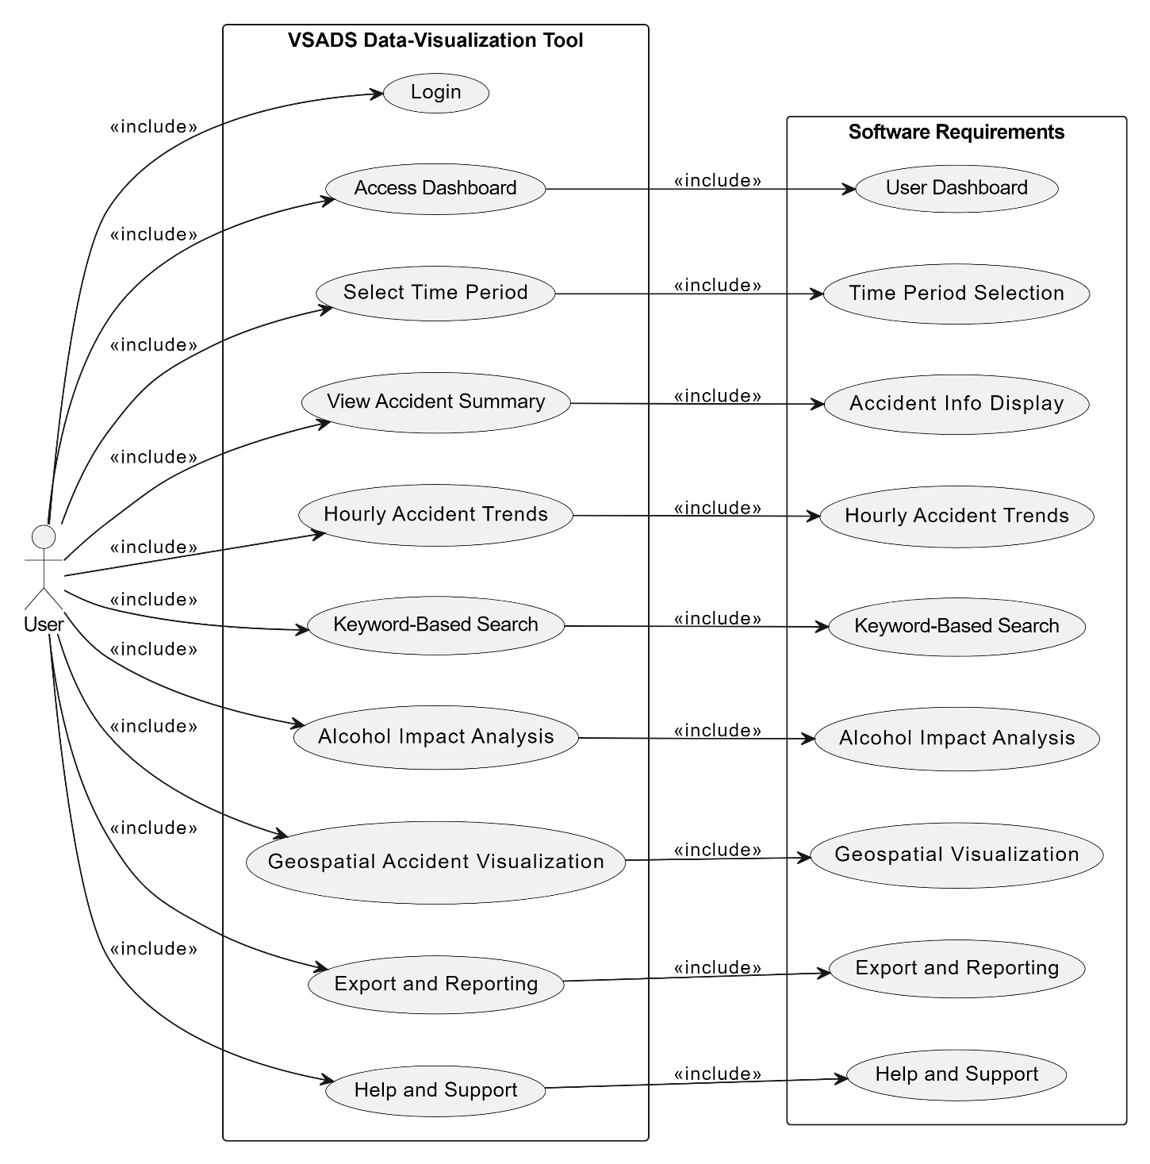

# Software Design and System Components

## Software Design

A block diagram/flowchart of how your software might work

## System Components

### Functions

Preliminary list of all functions in the software. For each function in the list the following information is provided:

* a brief description of what it does (1 or 2 sentences);
* a list of the input parameters, and their data types, and what they are used for;
* a list of any side effects caused by the function (ie change global or member variables, changes data passed by reference from calling function etc)
* a description of the function’s return value

### Data Structures / Data Sources

List of all data structures in the software (eg linked lists, trees, arrays etc) or eternal data sources. For each data structure in the list the following information is provided:

* Type of structure (tree, list etc),
* Description of where and how it is used
* List of data members, and what each one is for do
* List of functions that use it

### Detailed Design

Pseudocode for all non-standard / non-trivial algorithms that operate on data structures

# User Interface Design

This is your initial interface design. Describe the tools you used for this design stage and any key findings that informed your design. This introduction is descriptive and should explain what you have completed for the actual design work you will present in the sub-sections below.

## Structural Design

Structural design refers to the navigational and information structure of your product – the structure that supports the interface layout. How will you structure your product? How will you group your information? How will you navigate through your product? Why? This can take the form of a diagram showing structure and hierarchy, supported by a discussion and justification of your choices. Why have you made these design choices? Describe and outline the structure of your interface and of your information.

## Visual Design

Detail your visual design: Layout, visual elements, icons, graphics, style, colour, fonts general screen designs. This can be sketches, wireframes, mockups etc, supported by a discussion, explanation, and justification of your choices.